**Appendix 10. Calculating the probability of detecting northern pike with gillnetting efforts.**

Between 2005 and 2010, ADF&G conducted 12 removal experiments with northern pike populations on the Kenai Peninsula using similar sampling methods. Data collected from these experiments included catch $C_{ij}$ and effort $E_{ij}$ (in units of net-hours per surface acre) for sample $i (i=1, …, s)$ and experiment $j \left(j=1, …, 12\right).$ Populations are assumed to be closed except for fish caught and the fishing is assumed to represent a Poisson process with a constant probability of capture for all individuals. Data was analyzed using a hierarchical version of Leslie’s regression method (Seber 1982):

$${CPUE}_{ij} = K_{j}N_{j} - K_{j}C_{ij}^{*}$$

where:

$${CPUE}_{ij}= {C_{ij}}/{E_{ij}}$$

$$C_{ij}^{*} = \sum_{k=1}^{i-1}{C_{kj}} for \left(i in 2, …, s+1\right) with C_{1j}^{*}=0$$

$N_{j}$ = the initial population size in experiment j

$K_{j}$ = average probability that a fish is captured with one unit of effort during experiment j,

The probabilities of capture for each experiment are assumed to come from a common distribution:

$$K_{j} \sim beta\left(a, b\right)$$

The analysis was conducted using the RJAGS package (Plumber 2013) within R (R Core Team 2016). Non-informative priors were used for all parameters. Although Leslie’s method is typically used to estimate the initial population size our interest was in the posterior and predictive distributions of $K$ for the purpose of estimating the probability of detecting small pike populations in future removal experiments.

Percentiles from the predictive distribution for the value of *K* in a new removal experiment are shown in Table 1 and the predictive distribution is shown in Figure 1.

**Table 1: Percentiles from the predictive distribution of *K*.**

|  |  |
| --- | --- |
| Percentile | predicted *K* |
| 5% | 0.001 |
| 10% | 0.003 |
| median | 0.019 |
| 90% | 0.055 |
| 95% | 0.073 |

**Appendix 9. page 2 of 3**

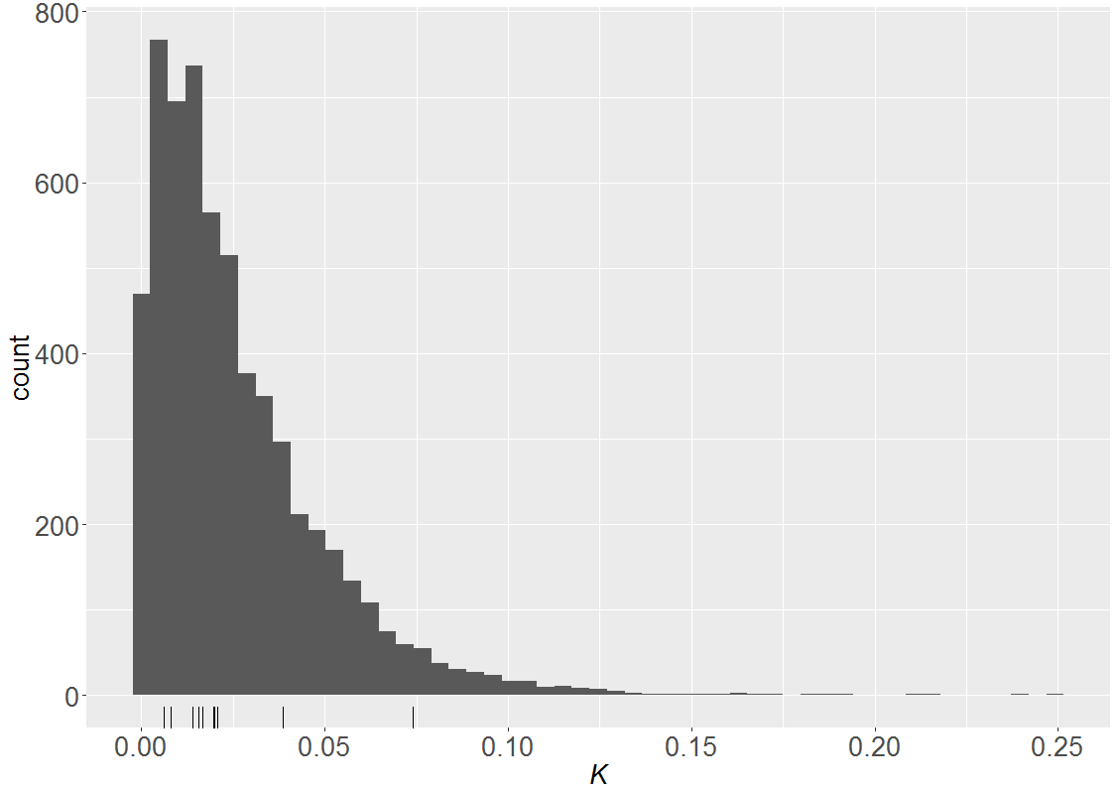

**Figure 1: Prediction distribution for *K, the average probability a fish is captured in a new removal experiment with one unit of effort. Tick marks along the x-axis show the median values for Kj, the average probability a fish is captured with one unit of effort in each of the previous removal experiments.***

Under the assumption that fishing represents a Poisson counting process, the probability of failing to detect a population of pike of size N as a function of net-hours per acre (E) is:

$D_{p}=$ = ${exp⁡(-KE)}^{N}$

We will use the median value of K from Table 1 to calculate probabilities. The value of effort will be chosen based on logistical considerations such as the number of nets and technicians available.

**Table 2: Probability of failing to detect a population of 20 pike with various levels of netting effort.**

|  | **Net Densities** | | | |
| --- | --- | --- | --- | --- |
|  | **0.1nets/sa** | **0.25nets/sa** | **0.5nets/sa** | **0.75nets/sa** |
| **24 hours** | 0.391 | 0.096 | 0.009 | 0.001 |
| **48 hours** | 0.153 | 0.009 | 0.000 | 0.000 |
| **72 hours** | 0.060 | 0.001 | 0.000 | 0.000 |